Bring a Friend
and enjoy our
Holiday Sale @ the pottery studio!
Sat., Nov. 19, 2022
10am - 4pm

MEET published authors, teachers & artisans.

Bring a friend for a delightful holiday studio shopping experience.
Buy yourselves a treat!
Available: pottery, art, tea, scones and books!

Home Studio Location: 7290 Fawn Hill Road, Chanhassen, MN 55317
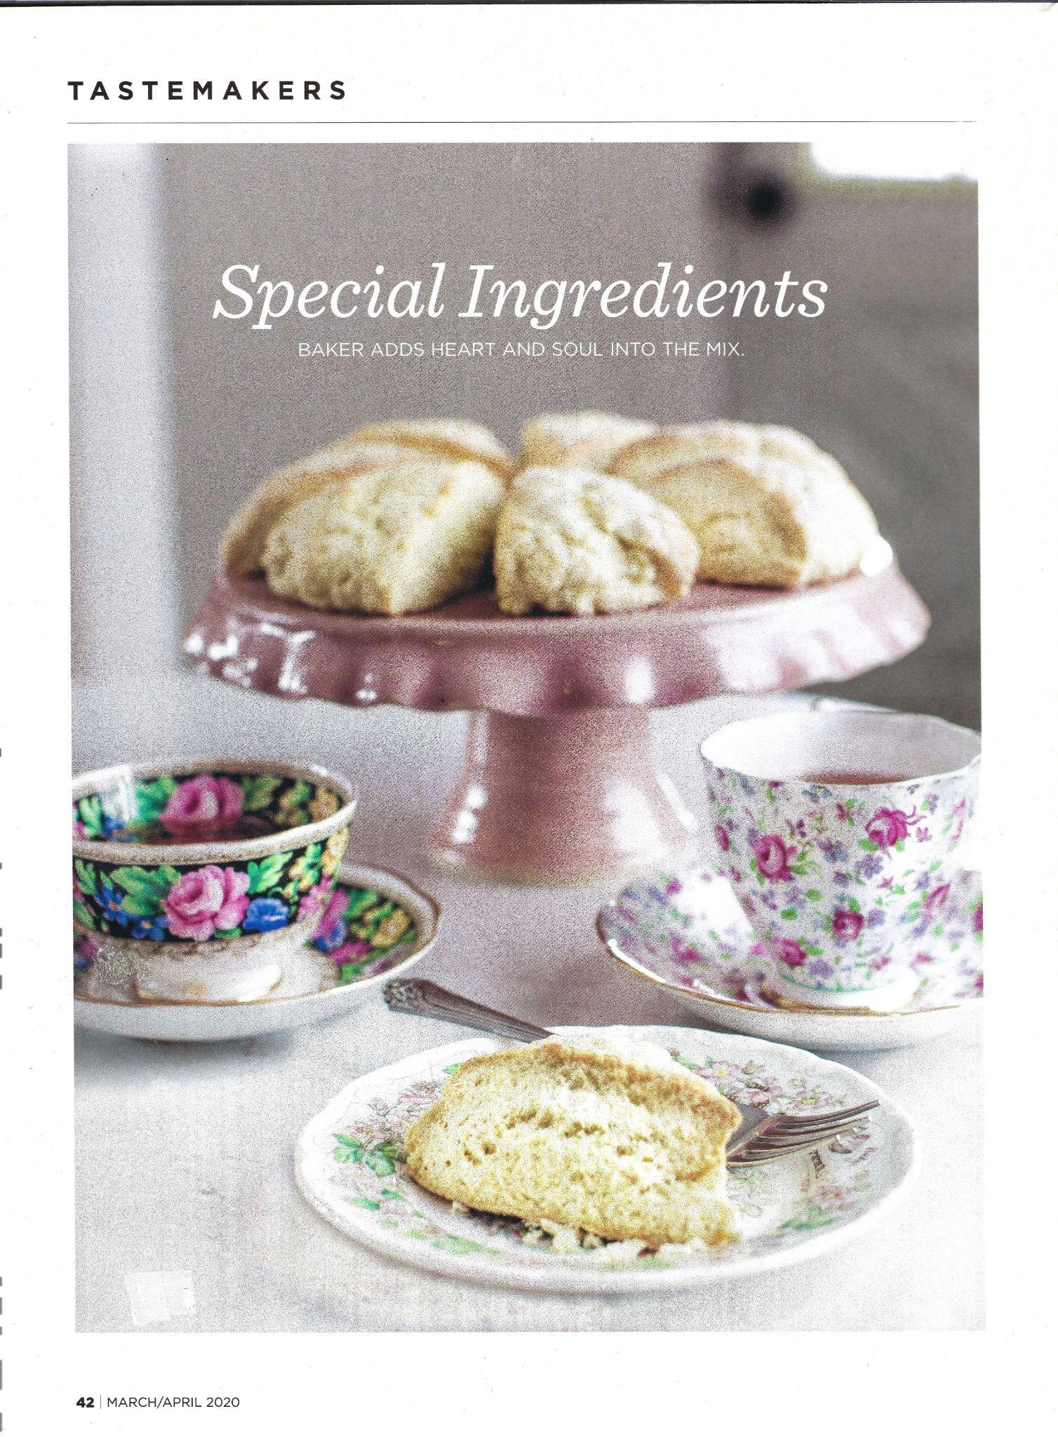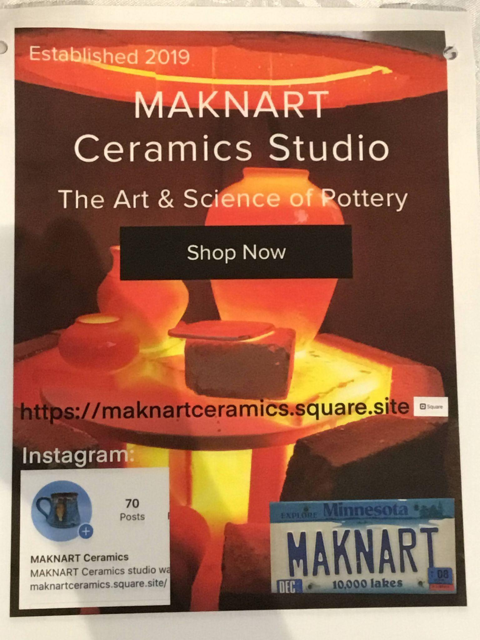
https://www.victoriastreetbakery.com/ https://maknartceramics.square.site/

